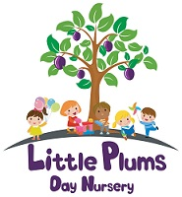
Oak Tree Children’s Centre
Children need to have a go so they can learn…… let them try, and try again knowing you are there to catch them and say well done!
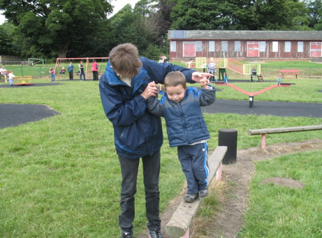

Lets talk:
In/On
Up/Down
Under/
Over
Step
Slide
Stop/Go
Swing
Higher
Lower
Faster
Slower

It's fun to play outdoors

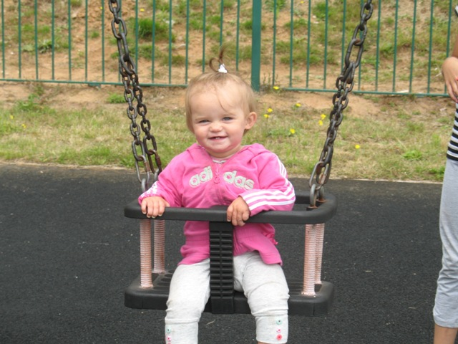
Simple games to play on the park:

Sliding down the slide
Ready, Steady, Go
Singing songs on the see-saw like Row, row, row your boat and See-saw Margery Daw
Counting the steps as you climb and pushes on the swings
Peek-a-boo
Encourage your child to pretend e.g “You’re the train driver” “We’re going fast”
This will help your child develop their language as well as their physical skills by having fun, being active and talking together.
Games you can play!


